 Translated from Chinese (Simplified) to English - www.onlinedoctranslator.com
Northwest Agriculture and Forestry University
2021 PhD Dissertation
Project Proposal

Study on the mechanism of action of Sl5R-1 gene in tomato against spotted wilt
Mechanistic Study of Sl5R-1 MediatedResistance to Tomato Spot Wilt Virus inTomato

College (Department, Institute) College of Horticulture
First-level discipline/professional field Vegetable Science
Graduate student name and student number Wang Bo 2021060154
Instructor's Name Liang Yan (Professor)
Name of the leader of the thesis discussion group
Names of members of the thesis discussion group

Graduate students pass the thesis proposalArgumentdate: years day

Table of contents
1. Purpose and significance of the topic 1
(II) Basis for topic selection (theoretical basis, technical basis, and basis for previous work and research) 2
2.1 Theoretical basis 2
2.2 Technical basis 3
2.3 Research Basis of Preliminary Work 4
2.4 Current work progress 6
3. Overview of domestic and foreign research 8
3.1 Research progress on tomato spotted wilt 8
3.2 Research status of tomato spotted wilt resistance genes and disease resistance mechanisms 9
3.3 Research progress on TGA transcription factors 14
(IV) Research content 16
4.1 Construction of tomato Sl5R-1 knockout transformed plants based on CRISPR-Cas 9 gene editing technology and transcriptome analysis 16
4.1.2 RNA-Seq analysis of TSWV-treated Sl5R-1 overexpression and knockout materials 16
4.2 Analysis of key signaling pathways affecting the anti-TSWV immune function of Sl5R-1 16
4.2.1 Verification analysis of key gene expression using RT-qPCR based on transcriptome differential enrichment analysis 16
4.2.2 Silencing candidate genes in Sl5R-1 overexpressing materials using VIGS technology and comparing their effects on disease resistance in Sl5R-1 overexpressing materials 16
4.2.3 Comparative analysis of the characteristics of immune responses involving key signaling pathways in Sl5R-1 overexpression and knockout materials and control plants after TSWV inoculation 16
4.3 Analysis of the role of transcription factor SlTGA9 in regulating the transcriptional expression of Sl5R-1 16
4.4 Further exploration of key target proteins interacting with Sl5R-1 based on transcriptome-proteome association analysis 17
4.4.1 IP-MS analysis using the constructed Sl5R-1 overexpression material with GFP tag and control transformed plants 17
4.4.2 Screening of potential interaction targets of Sl5R-1 through correlation analysis of transcriptome and proteome (mass spectrometry data) 17
4.4.3 Further verification of the interaction between Sl5R-1 and candidate target proteins using yeast two-hybrid and fluorescein interaction analysis 17
4.4.4 Verification of the effect of target protein on S15R-1-mediated immune function 17
(V) Research methods and technical routes 17
5.1 Research Methods 17
5.2 Technical route twenty one
(VI) Expected Results twenty one
VII. Innovation of this study twenty one
8. The main instruments, equipment and reagents required for graduate students engaged in natural science research, and the working conditions required for graduate students engaged in humanities and social sciences twenty two
9. Arrangements for the progress of thesis work twenty two
(X) Budget Estimates twenty three
11. Technical difficulties encountered in the research work and the solutions to be adopted twenty four
12. References twenty four

1. Purpose and significance of the topic
Tomato spotted wilt virus is caused by the Bunyaviridae family (Bunyaviridae)Tomato spotted wilt virusTospovirus)Tomato spotted wilt virus (Tomato spotted wilt virus, TSWV) caused by (Li Yunzhou et al., 2018;Huang. 2021). This virus is a plant RNA virus with a wide host range, including both dicotyledonous plants and monocotyledonous plants. It is highly pathogenic and can infect up to 100 families and 1090 economic crops (Kormelink et al. 2011;Oliveret al. 2016), causing huge economic losses in vegetables and ornamental plants. Severe outbreaks of spotted wilt can cause devastating damage or even crop failure (Riley et al. 2004; Sevik et al. 2012; Yoon et al. 2019; Nivethaa et al. 2021). In addition, TSWV is one of the few plant viruses in nature that spreads in a cyclical and multiplicative manner. Once the vector, western flower thrips, carries the virus for life, the virus can replicate and proliferate in the vector insect, which increases the efficiency of virus transmission (Jones 2005; Turina et al. 2016). Therefore, its spread range is relatively wide, and the diseases it causes are distributed worldwide (Figure 1). At present, there is no effective prevention and control method for TSWV and strong broad-spectrum resistant varieties. Based on scientific and economic importance, it ranks second among the top ten plant viruses (Scholthof et al. 2011).
Currently, the virus can be identified by eight TSWV resistance genes, of which only Sw-5 has broad-spectrum resistance to TSWV and is widely used in breeding. However, the Sw-5 resistance gene does not completely protect against TSWV. In some countries or regions, TSWV isolates that break the Sw-5 gene locus have appeared.Lopezet al. 2011; Qi et al. 2011). Although Sw-7 can produce resistance to TSWV isolates that overcome Sw-5, research is still in its infancy (Stevens et al. 2007). Therefore, discovering highly effective TSWV resistance genes through molecular biological methods is an effective way to accelerate disease resistance research.
In the early stage of the laboratory, the six SSR polymorphic markers developed were used to finely locate the major QTL and identify the candidate genes in the 1971 F2 population to obtain the tomato S15R-1gene, resistance to this geneTSWThe functions and signaling pathways involved have been preliminarily analyzed (Qi et al; 2022), but whether the transcription factor SlTGA9 can activate the upregulation of Sl5R-1 expression by binding to the binding sites on the promoter region of the Sl5R-1 gene to play an anti-TSWFunction, and Sl5R-1Is salicylic acid (SA) and jasmonic acid (JA) or other signal transduction pathways involved in the anti-TSWThe function is currently unclear.5R-1The mechanisms involved in regulating tomato immunity against TSWV are still unclear.
Based on the previous work of the research group, this study used the TSWV-resistant tomato variety H149 (S. lycopersicum var. cerasiforme) and the TSWV-susceptible tomato variety M82 (S. lycopersicumcv. M82) was used as the research object. By constructing tomato Sl5R-1Gene knockout genetic transformation materials were analyzed by transcriptome sequencing (RNA-seq), immunoprecipitation and mass spectrometry (IP-MS) and other methods to exploreSlTGA9The regulatory effect of Sl5R-1 on TSWV resistance was explored.5R-1Key factors and signaling pathways regulating gene resistance to TSWV,To clarify the function and mechanism of Sl5R-1 gene against TSWVTo promote tomato resistanceTSWMolecular breeding provides new strategies.
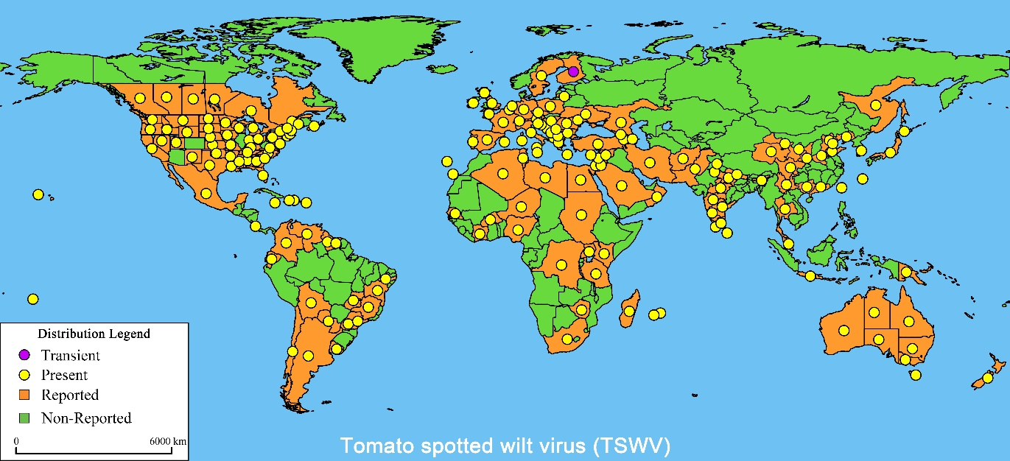
Figure 1 Global distribution of tomato spotted wilt disease (Qi et al. 2021)
Note: Purple marks indicate temporary infection, yellow marks indicate infection, orange marks indicate reported infection, and green marks indicate no reported infection.

(II) Basis for topic selection (theoretical basis, technical basis, and basis for previous work and research)

2.1 Theoretical basis
TSWV is a potential threat to tomato and other crop production. Due to global trade, thrips and the virus they carry continue to spread around the world, causing serious economic losses. However, there is currently no tomato variety that is highly resistant to TSWV.Pappu et al. 2009). Although the Sw-5 gene exhibits broad-spectrum resistance to TSWV and is widely used in commercial breeding, Sw-5 is not completely immune to TSWV, and the resistance of the Sw-5 gene depends on allergic reactions and cannot provide lasting systemic resistance (Huang. 2021). Although the Sw-7 gene is a dominant quality gene that can confer resistance to TSWV isolates that overcome Sw-5, there is still little research on the location and cloning of the Sw-7 gene (Price et al. 2007; Qi et al. 2021). Therefore, it is helpful to accelerate the process of tomato resistance breeding by mining highly effective TSWV resistance genes from the screened resistant materials, systematically analyzing the plant disease resistance mechanism at the molecular level, and revealing the disease resistance signal transduction pathway.
At present, breeding new tomato varieties resistant to TSWV is an important task in disease-resistant breeding research, but people often do not have a deep understanding of the mechanisms of plant resistance to diseases, which hinders disease resistance research. In addition, with the continuous deepening of biological research, the study of single gene and protein functions cannot fully explain the intricate relationships of living organisms. Therefore, with the help of molecular means, sequencing technology and bioinformatics methods, RNA-Seq technology, IP-MS, yeast single-hybrid and two-hybrid systems and other technologies can effectively determine the regulatory network relationships formed by different key regulatory factors, clarify the signal transduction pathways involved in plant disease resistance, and thus systematically reveal the plant disease resistance mechanism, which plays a key role in tomato resistance breeding and cultivation production. It has been used in tomato blight (Jiang et al. 2019) Tomato spotted wilt (Padmanabhan et al. 2019) Grape downy mildew (Bhatia et al. 2021) Barley leaf spot (Sjokvist et al. 2019), beet brown spot disease (Gong Yunhe, 2022), melon yellow leaf curl disease（Sáezet al. 2022) and other crops for disease resistance.

2.2 Technical basis
RNA-seq is a transcriptome sequencing technology that uses high-throughput sequencing technology to sequence and analyze DNA libraries to study their expression levels. It can clearly and comprehensively reflect the differential expression levels of genes in different biological tissues at different developmental stages and under different environmental conditions at the molecular level, and then explain the expression and regulation of genes, revealing specific biological processes and the molecular mechanisms of disease occurrence. It has been widely used in the agricultural field and has achieved many results. For example, transcriptome analysis was used to identify TSWV-related defense genes in the tomato Sw-7 line, and a large number of differentially expressed genes were found, including pathogenesis-related genes 1 (PR1) and 5 (PR5), serine/threonine kinase proteins, and RNA silencing pathway genes, providing an opportunity to understand the disease resistance mechanism of TSWV (Padmabhan,et al. 2016; Padmanabhan et al. 2019). Through BSA-seq and RNA-seq analysis, candidate genes related to resistance to Tomato yellow leaf curl virus (TYLCV) were mined, and 9 candidate genes related to resistance to TYLCV were identified (Chen et al. 2019).
IP-MS is an important method for studying protein interactions. It uses fixed antibodies targeting specific proteins. The sample is incubated with the antibody under non-denaturing conditions, and then the target protein (bait) and its interacting proteins (prey) bind to the antibody, while non-interacting proteins pass through or do not bind to the matrix. The captured protein complexes are further analyzed by proteomics such as mass spectrometry (Pheeet al. 2006). Its advantage is that it is based on the specificity between antibodies and antigens. It can not only verify known interacting proteins, but also screen the interactions between proteins that remain in the original lysed cells under physiological conditions. The target protein is identified by antibody specificity, and the interacting proteins of the target protein are precipitated at the same time (Berggård et al. 2007). In the past decade, the molecular identification technology of protein and peptide based on biological mass spectrometry has made great progress. Mass spectrometry equipment has gradually matured, making identification analysis faster and more accurate. In addition, Co-IP can retain the original modification and binding state of the protein, requires less sample volume, has lower experimental costs, reduces purification steps, and can detect transient and weak protein interactions. Although Co-IP technology requires specific antibodies, which is an obstacle to large-scale screening of unknown proteins, in recent years, by fusing small molecule tag proteins such as HA, Flag, cMyc, etc., the cost of the experiment has been greatly reduced (Brown et al. 2017).
In addition, our research group has established a complete TSWV disease resistance evaluation system on tomatoes, with mature technical systems such as tomato transcriptome analysis, gene cloning, overexpression and knockout vector construction, and tomato genetic transformation. The experimental instruments and equipment are complete. By reading a large amount of relevant scientific research literature in the early stage of the experiment and mastering the experimental skills, a solid foundation has been laid for the smooth implementation of the experiment.

2.3 Research Basis of Preliminary Work
2.3.1 Structural and phylogenetic analysis of Sl5R-1 protein
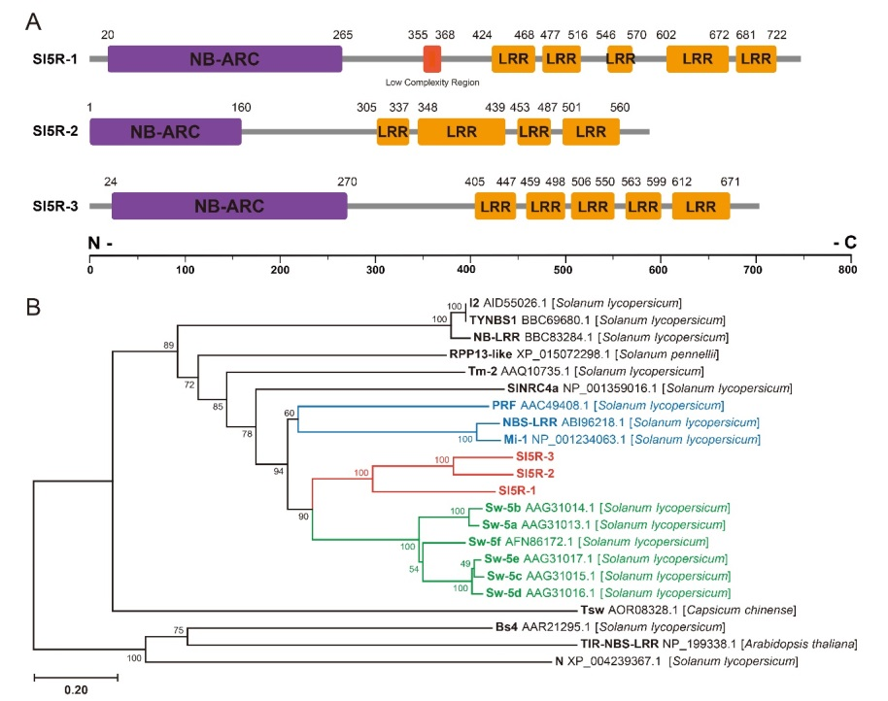
Figure 2 Structural and phylogenetic analysis of Sl5R-1 protein (Qi et al. 2022)
Previous studies have confirmed that Sl5R-1 is a typical R gene, which encodes a typical NB-LRR protein, including APAF-1, R protein, CED-4 (NB-ARC) and LRR domains. Sl5R-1 and Sw-5b are highly conserved in the NB, ARC1, ARC2 and LRR domains. Sl5R-1 is likely to be a key gene for resisting TSWV (Figure 2).
2.3.2 Analysis of the binding sites between Sl5R-1 and transcription factor SlTGA9 in M82 and H149 materials
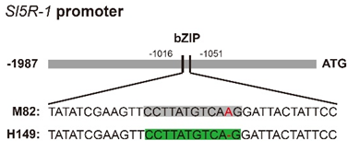
Figure 3 Binding sites of Sl5R-1 and transcription factor SlTGA9 in M82 and H149 materials (Qi et al. 2022)
The sequence alignment of the Sl5R-1 coding region in M82 and H149 plants is completely consistent. The promoter sequence alignment found that M82 (CCTTATGTCAAG) has one more base A at position 973 than H149 (CCTTATGTCAG). The motif (CCTTATGTCAG) at this position is the position where the Sl5R-1 promoter in H149 can bind to the predicted transcription factor SlTGA9, while M82 cannot interact due to the extra base (Figure 3). Based on the above analysis, the motif (CCTTATGTCAG) at position 973 of the promoter sequence is likely to play an important role in the resistance of M82 and H149 plants to TSWV.
2.3.3. The regulatory mechanism of Sl5R-1 in TSWV resistance in M82 and H149
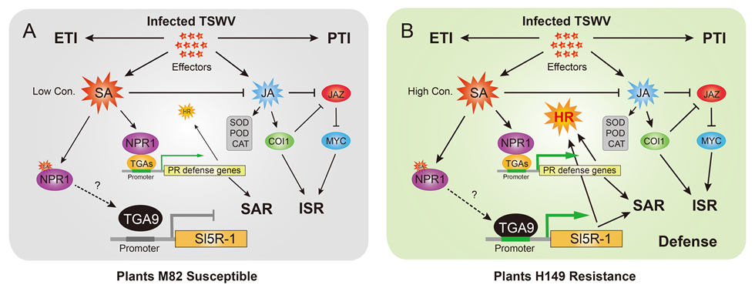
Figure 4 Regulatory mechanism model of Sl5R-1 involved in TSWV resistance in M82 and H149 plants (Qi et al. 2022)
In TSWV-infected susceptible plant M82, the SlTGA9 transcription factor could not bind to the Sl5R-1 promoter region, resulting in the inability of Sl5R-1 to activate transcriptional expression.-The transcription level of signaling pathway regulatory genes is relatively low, leading to systemic acquired resistance (systemic acquired resistance, SAR) is very weak. The relevant defense genes can only produce very weakAllergic necrosisHR response.forSusceptibility traits(Figure 4).
In H149A more reasonable explanation for the high resistance is that the transcription factor SlTGA9 interacts with Sl5R-1 or positively regulates Sl5R-1, which upregulates the transcriptional activity of Sl5R-1 and affects the SA and JA signaling pathways.This leads to a large accumulation of SA, strongly inducing the upregulation of resistance defense genes and enhancing the SAR response. On the other hand, the immune response triggered by pathogen-associated molecular patterns (PAMPs) in the two-layer immune system of tomato plants (PAMP-Triggered Immunity, PTI) and effector-triggered immune responses (effector-triggered immunity, ETI) is triggered, and the JA-mediated induction of systemic resistance ISR is greatly enhanced,At the same time, HR response complex is produced at the site of TSWV infection to resist the invasion of TSWV.Finally, the H149 plant was endowed with TSWV resistance regulation (Fig.4).However, the inference needs to be further confirmed or demonstrated in subsequent experiments. In short, the Sl5R-1 located in the previous research of this project is resistant to TSWV and is a new disease resistance gene found in tomato spotted wilt resistance breeding, which provides a scientific theoretical basis for the subsequent in-depth study of the disease resistance mechanism of tomato spotted wilt.

2.4 at presentWorkProgress
2.4.1 Subcellular localization of Sl5R-1 in tobacco leaves
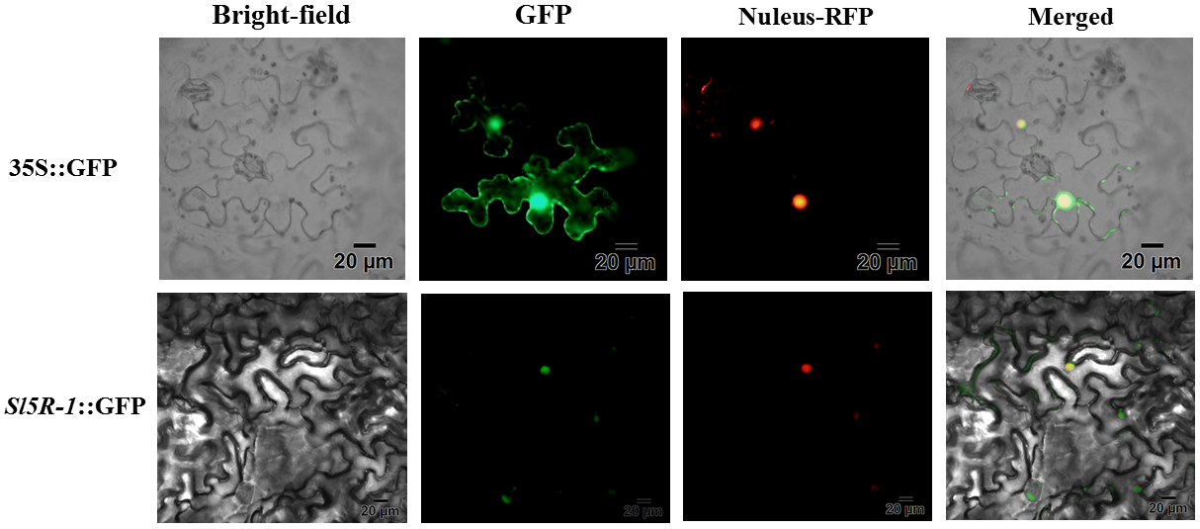
picture5Subcellular localization of Sl5R-1 in tobacco leaves
Subcellular localization in tobacco leaves revealed that Sl5R-1 was localized in the cell nucleus, indicating that it exerts its disease resistance function in the cell nucleus ( Figure 5 ).
2.4.2 Comparison of CDS sequences of SlTGA9 from H149 and M82 materials
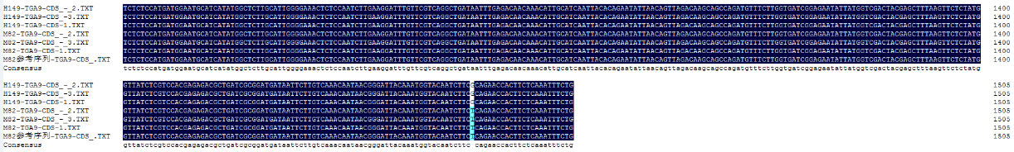
Fig.6 Sequence alignment of the coding region of SlTGA9 in H149 and M82 materials
Although the CDS sequences of the transcription factor SlTGA9 of M82 and H149 materials differ by one base, the codons they consist of encode the same amino acid and the proteins translated by CDS are the same, indicating that the CDS sequences of SlTGA9 of the two materials have the same function and there is no difference (Figure 6). In addition, it is predicted that the Sl5R-1 gene of H149 material can interact with SlTGA9, while the Sl5R-1 of M82 material cannot interact with SlTGA9. Whether or not they can interact with SlTGA9 may be due to the different promoter sequence motifs of Sl5R-1 of the two materials, which has nothing to do with the CDS sequence of SlTGA9.
2.4.3 Yeast one-hybrid dot-to-dot assay of Sl5R-1 and SlTGA9 - analysis of promoter activity
Fig.7 Analysis of Sl5R-1 promoter activity in H149 material
Fig.8 Analysis of Sl5R-1 promoter activity in M82 material
As shown in Figures 7 and 8, the Sl5R-1 promoter activity in the H149 material corresponds to 100 mM 3-amino-1,2,4-triazole (3-amino-1, 2, 4-triazole, 3-AT) can be used as the background concentration; in the M82 material, 140 mM 3-AT corresponding to the Sl5R-1 promoter activity can be used as the background concentration, indicating that the interaction verification between Sl5R-1 and SlTGA9 is suitable for the yeast one-hybrid system.

3. Overview of domestic and foreign research

3.1Research progress on tomato spotted wilt
3.1.1 Characteristics and transmission of tomato spotted wilt virus
Tomato spotted wilt is the most destructive disease affecting tomato planting and production after Tomato Yellow Leaf Curl Virus. TSWV belongs to the Tospovirdae family of the Bunyavirales order, the Orthotospovirus genus, and the Tospovirus genus. It is the only virus found to infect plants. Researchers have divided TSWV into 16 groups based on the similarity of the virus coat protein sequence and molecular evolution. They are distributed in Asia, South America, North America, Africa, Europe, etc. (Qiet al. 2021), our research group cloned the TSWV virus strain isolated in Yangling, Shaanxi, and found that it had a 99% similarity with Spanish pepper TSWV and was classified into the same group (Mo Ning et al., 2019).
TSWV is a type of RNA spherical virus, and the virus particles are flat spherical,Easy to deform,diameter80-96 nm,With membrane structure, the outer layer of the membranehaveContinuous layers of protrusions.The lethal temperature of the virus particles is40~46℃, in vitro survival period is3~4hThe genome belongs to negative single strandRNA, eachRNAEnd of fragment approx.65The nucleotide sequences are complementary and the regions are complementary, thus forming a pseudo-circular structure.Its genome contains three RNA chains, L RNA, M RNA and S RNA, encoding a total of 5 proteins（Kormelink et al. 2011）L RNA is negative-sense RNA, encoding RNA-dependent RNA polymerase (RdRp), which has replication-related proteins and can work together with host coding factors; M RNA is double-sense RNA, and antisense RNA encodes riboprotein precursors (The amino and carboxy terminal position within the glycoprotein precursor, G_{N}G_{C}), positive RNA encodes viral non-structural movement proteins (NSm), which mainly promote TSWV infection of plants; S RNA is a double-sense RNA, antisense RNA encodes nucleocapsid proteins (N), and positive RNA encodes non-structural proteins (NSs), both of which play a key role in the TSWV infection cycle.（Ocampo et al.2016;Qi et al. 2021）.
TSWV has a wide range of susceptible hosts, especially tomatoes, peppers, potatoes and tobacco.(Frankliniella occidentalis)is considered to beTSWThe most effective vector of transmission, the western flower thrips, which carries TSWV, has asymmetric mouthparts and sucks plant sap. The damaged cells are easily infected by the virus it carries and continue to reproduce (Rajarapu et al. 2022). In addition, western flower thrips spreads in a persistent proliferation manner.TSW, cannot be transmitted through eggs, and once the nymph carries the TSWV virus, it will carry the virus for life. The younger the nymph, the stronger its ability to acquire the virus.1996In 2012, my country listed it as a potentially dangerous pest for imported plant quarantine (Qiu Shuliang et al., 2012). Due to the lack of effective control measures and disease-resistant varieties, this destructive virus has spread rapidly in a variety of field crops and protected land, causing more than 10 million tons of crop yield reduction in agriculture, horticulture and ornamental plants around the world each year.10USD 100 million (Yin Yueyan et al., 2018). Tomato spotted wilt virus can also be transmitted through juice friction inoculation, grafting, etc., but it cannot be transmitted through daily contact or through seeds.
3.1.2 Symptoms of tomato spotted wilt
Symptoms of TSWV systemic infection of plants vary depending on the host species, age, and environmental conditions.Masriet al. 2021). Typical symptoms include the appearance of ring-shaped lesions on leaves, leaf stems, and fruits, dwarfing and wilting of plants, asymmetrical growth, and in severe cases, necrosis of the entire plant (Morca et al. 2022). Infected in the seedling stage, the color of young leaves turns copper and curls up, and then black necrotic spots form. The back of the leaves gradually turns purple along the veins, and brown necrotic streaks appear at the stem end. The diseased plants grow slowly, become completely dwarfed, and wilt. If infected early, it may cause fruit failure (Padmanabhan et al. 2019). Infected after fruit setting, light green ring spots appear on the fruit, the fruit is slightly raised, and fine ring patterns appear. Brown necrotic spots appear on the green fruit, which are tumor-like protrusions, and the fruit is easy to fall off. When the ripe fruit is infected, the rings are obvious, and red and yellow or red and white ring spots appear. The chlorotic spots are obvious during the full color stage. In severe cases, the whole fruit turns brown, necrotic and shrunken (Sandani et al. 2018).

3.2Current status of research on tomato spotted wilt resistance genes and disease resistance mechanisms
3.2.1 Tomato spotted wilt resistance genes
Currently, inCultivated tomatoes, wildtomatowaitMaterialFind the antiTSWgenetic resources,Eight TSWV resistance genes identified(Table 1)：Sw-1a, Sw-1b, Sw-2, Sw-3, Sw-4, Sw-5, Sw-6, Sw-7（Roselló et al. 2018; Qiet al. 2021). Among them, Sw-1a, Sw-1b, Sw-2, Sw-3, Sw-4, and Sw-6 are only resistant to specific TSWV subspecies, but they are quickly destroyed and are rarely used in commercial breeding.
Sw-5It is the most studied and most widely used resistance gene in commercial breeding. Sw-5 is a single dominant quality disease resistance gene.The protein is a typical CC-NB-ARC protein.Broad spectrum resistance gene, the gene cluster contains 6 homologous paralogous genes Sw-5a, Sw-5b, Sw-5c, Sw-5d, Sw-5e and Sw-5f (Stevenset al. 1995), among which only Sw-5b has broad-spectrum resistance to different physiological subspecies of TSWV and is a key gene for resistance to TSWV. Although Sw-5 is widely used in tomato resistance breeding hybrids, it is not completely immune to TSWV and will be overcome under high concentrations of TSWV virus treatment (McMichael et al. 1995), and its resistance is limited. Sw-7 was identified by Price et al. from the breeding line Y118 selected from the hybrid offspring of Chilean tomato LA1938 and cultivated tomato. It is a single gene dominant quality disease resistance gene that can produce resistance to TSWV subspecies that overcome the Sw-5 gene, and the resistance mechanism is different. This gene has a strong effect on resistance to TSWV, but there has been no substantial progress in tomato resistance breeding (Qi et al. 2021).
Therefore, facing the constantAppearTSWV with strong toxicityChangespecies, collect new resistance resources and explore resistance to TSWVnewGene,In-depth research onTSWThe disease resistance mechanismrightaccelerateTomato resistance breeding and cultivation production are crucial.
surface1 Tomato TSWV virusResistance gene list information(Qi et al. 2021)
Gene name  Gene Name | Gene cluster  Gene Cluster | Sources  Material Source | QTL Mapping  QTL Mapping | Genetic distance (cM)  Genetic Distance | chromosomeposition  Chromosome Mapping
Sw-1 | Sw-1a  Sw-1b | L. pimpinellifoliumMill.
Sw-2 |  | L. pimpinellifoliumMill.
Sw-3 |  | L. pimpinellifoliumMill.
Sw-4 |  | L. pimpinellifoliumMill.
Sw-5 | Sw-5a  Sw-5b  Sw-5c  Sw-5d  Sw-5e  Sw-5f | L. peruvianum Mill. | CT71-CT220  CT220-SCAR421 | 1.6-2.7  0.28-0.64 | 9
Sw-6 |  | L. peruvianum Mill.
Sw-7 |  | L. chilenseDun. | T11263-SSR20 | 45.0-58.2 | 12
3.2.2 Research progress on plant resistance genes NBS-LRR
Plants are attacked by various pathogens (bacteria, viruses, fungi, and oomycetes) during their growth. In order to adapt to the environment, plants have gradually formed a series of complex defense mechanisms in the long-term evolution process.（Resistance, R）Genes give plants the ability to resist various pathogens (Meyers et al. 2003). Although the pathogenic factors are different, the R gene is very conservative in its structural characteristics.according toThatSequence characteristics and structural analysis usually divide R genes into five categories: NBS-LRR (Nucleotide-Binding Site-Leucine Rich Repeat, nucleotide binding site-leucine-rich repeat motif) class, LRR-TM (Leucine-Rich Repeat-Transmembrane Receptor, leucine-rich repeat-transmembrane domain) class, STK (Serine-Threonine Kinase, serine-threonine kinase) class, RLK (Recepetor-Like Kinase, receptor kinase) class and SA-CC (Signal Anchor-Coiled-Coil, signal-anchored coiled-coil) category. Among them,NBS-LRR is one of the largest gene families in plant genomes and also the disease resistance gene family with the largest number of genes (Huang et al. 20twenty one;Fick et al. 2022).
Studies have shown that NBS-LRR disease resistance genes mainly include two domains: Nucleotide-Binding Site (NBS) and Leucine-Rich-Repeat (LRR) region. According to the different domains of the N-terminal of the protein encoded by NBS-LRR genes, they are divided into two subclasses: one is TNL (TIR-NBS-LRR) genes, whose N-terminal encoded protein has a structure similar to Toll/interleukin-1 receptor (Toll-interleukin-1 receptor, TIR); one is the CNL (CC-NBS-LRR) gene, which encodes a protein with a coiled-coil domain at the N-terminus (coiled-coil, CC), these structures are usually important components of disease-resistant proteins, among which the NBS region is the most conserved domain and exists in different types of proteins, such as ATPase, GTP-binding protein, elongation factor heterotrimer, etc. (Zhou et al. 2021). The NBS domain can bind to ATP or GTP, causing protein phosphorylation/dephosphorylation to participate in the conduction of disease resistance signals. The LRR domain is mainly involved in protein-protein interactions. The sequence is rich in leucine and can interact with pathogenic non-toxic proteins. Under the pressure of diversity selection, its sequence changes greatly. It is speculated that the protein encoded by the NBS-LRR gene recognizes pathogens through LRR and senses signals, participating in gene transcription regulation (Belkhadir et al. 2004). The amino acid sequences encoded by NBS-LRR disease resistance genes are highly conservative. Currently, researchers usually design primers based on the conservative structure of the NBS region of the NBS-LRR disease resistance gene to perform PCR amplification of resistance gene analog sequences (RGAs) to isolate and clone plant NBS-LRR genes, and develop molecular markers for molecular-assisted selection and disease resistance gene map-based cloning, etc. (Lin et al. 2013;Soriano et al. 2005; Niu et al. 2011).
at presentThe NBS-LRR disease resistance genes in the whole genome of tomatoes have been mined and studied, and the analysis shows that the similarity between NBS-LRR disease resistance genes and tomato TSWV resistance genes is as high as more than 90% (Liu Yunfeiwait,2014)In addition, the reported tomato TSWV resistance gene Sw-5b contains the NBS-LRR disease resistance gene domain and has broad-spectrum resistance. Previous studies of this project have shown that the NB, ARC1, ARC2 and LRR domains of Sl5R-1 and Sw-5b are highly conserved, providing a basis for Sl5R-1 to resist TSWV.Therefore, in-depth exploration and research on tomato NBS-LRR disease resistance genes and their structural domains will be beneficial toclearTomato disease resistance related genesFunction, providing effective technical support for disease-resistant tomato breeding.
3.2.3 Mechanism of immune response to tomato spotted wilt
Plants face infection from a variety of pathogens during their development. During the long-term evolution, plants and pathogens interact, adapt to each other, and evolve together. On the one hand, in order to survive, plants gradually establish a series of complex defense mechanisms during evolution, and stimulate the plant's defense system, so that the plant produces disease resistance responses that can coordinate well against pathogen infection; on the other hand, pathogens inhibit induced defense responses by regulating the plant defense response-signal transduction pathway, breaking the plant's defense system and ultimately causing the plant to show symptoms. Therefore, understanding how these plant defense responses are regulated and activated when attacked by pathogens will help people deepen their understanding of the interaction mechanism between plants and pathogens and promote research on crop disease resistance breeding.
3.2.3.1 RNAi immune mechanism
RNA interference (RNAi) is a conserved regulatory mechanism that plays a vital role in gene regulation and defense against invading viruses (Dinget al. 2007). After the virus invades the plant, it triggers the RNAi immune mechanism with plant innate immunity to prevent the invasion of TSWV. The mRNA double-stranded nucleic acid (dsRNA) from the TSWV virus is effectively targeted and cut into 21-22 nt viral small interfering RNA (vsi RNAs) by the Dicer protein (RNAse III Dicer-like proteins, DCLs) of the RNA III polymerase family. The most significant feature of virus-induced gene silencing is the production of a large number of virus-derived vsi RNAs in infected tomatoes (Hamilton et al. 1999; Leonetti et al. 2021). However, the cleavage of DCLs alone cannot completely restrict the replication of the virus. Truly efficient antiviral RNA silencing also requires the participation of important components such as Argonautes protein (Argonautes, AGO) and RNA-dependent RNA polymerase (RNA-dependent RNA polymerase, RDR). The vsiRNA entering the AGO protein activates the RNA-induced silencing complex (RISC), further activating the degradation of the viral target RNA. However, in recent years, more and more silencing suppressors have been discovered. This is an anti-interference mechanism evolved by the virus to resist this RNA-based silencing defense mechanism. The functional proteins of many plant viruses have been used to study RNA silencing suppressors. For example, the NSs protein of the virus, as a silencing suppressor of TSWV, can combine with DCLs and AGOs to further inhibit the RISC activity in plants, thereby inhibiting the plant's own RNA silencing of TSWV (Li et al. 2019) (Figure 9).
3.2.3.2 Immune responses triggered by pathogen-associated molecular patterns
In the long-term evolution, plants have evolved two lines of immune defense to inhibit the damage of invading pathogenic microorganisms (including viruses, bacteria and fungi, etc.)Joneset al. 2016). The first line of defense is the immune response PTI triggered by pathogen-associated molecular patterns (PAMPs), which are triggered by pathogens outside the cell by activating receptors on the cell surface. The pattern recognition receptors (PRRs) on the cell surface include two types of recognition receptors: receptor-like kinases (RLKs) and receptor-like proteins (RLPs) (Yuan et al. 2021; Bjornson et al. 2021). Most pathogens have highly conserved molecular characteristics, namely PAMPs, including chitin in fungi, flagellin, peptidoglycan, lipopolysaccharide, etc. in bacteria. PRR will be activated after recognizing and binding to these conserved PAMPs, and then bind to BAK1 and phosphorylate each other to form an active complex. Finally, the phosphorylated PRR-BAK1 complex activates downstream MAPK or CDPK, causing effectors to trigger immune responses ETI, inhibiting the proliferation of pathogens and playing an immune role (Pruitt et al. 2021) (Figure 9).
3.2.3.3 Immune responses triggered by effector factors
When pathogens infect the plant surface, they will be recognized by PRR, causing the first layer of defense response PTI. However, some pathogens can secrete a variety of effector factors into host plant cells through the type III secretion system, modify a protein in the plant disease resistance pathway, inhibit or weaken the plant's defense mechanism, thereby promoting the proliferation of pathogens and ultimately causing plant disease (Muthamilarasanet al. 2013) (Figure 5). At this time, TNL proteins or CNL proteins in the nucleotide-binding leucine-rich repeat receptors in the plant R gene can directly or indirectly recognize and bind to pathogen effectors (Caplan et al. 2008; Tian et al. 2021), causing intracellular signal transduction and producing a strong hypersensitive necrosis response (HR), thereby restricting TSWV to the infection site and killing the pathogen in the invaded cells, thereby inhibiting the infection of pathogens (Mandadi et al. 2013; Chen et al. 2021). For example, in order to further combat the invasion of TSWV, CNLs from tomatoes (including Sw-5b proteins) can perceive effectors NSm and NSs, trigger immune ETI, and produce HR (Huang et al. 2018; Zhan et al. 2021; Zhao et al. 2021).
3.2.3.4 Signal transduction pathways of salicylic acid, jasmonic acid, ethylene and abscisic acid
Plant hormones SA, JA, ET and abscisic acid (abscisic acid; ABA) plays an important role in PTI and ETI and can activate the SAR of plants (Zamoraet al. 2021; Chen et al. 2021). Previous studies of this topic have confirmed that TSWV infection significantly upregulates SA synthesis and increases SA-related defense (Nachappa et al. 2020; Qi et al. 2022). SA accumulates in the infected area and then induces the rapid transcriptional activation of a series of R genes (Huang et al. 2021), which further triggers HR (Figure 4). Therefore, the SA signaling pathway may play a key role in the basal defense of tomato plants against TSWV (Beris et al. 2018). In TSWV-infected plants, JA-related responses are inhibited by SA, and this process mainly occurs downstream of the JA biosynthesis pathway (Leon-Reyes et al. 2010). The upregulation of ABA-related genes leads to the inhibition of SA-mediated defense (Asselbergh et al. 2010). Both JA and SA can induce the expression of PR genes. Studies have shown that the pathogenesis-related proteins PR-1 and PR-5 are associated with Sw-7 resistance and may play a major role in resisting TSWV infection (Padmabhan et al. 2016). Therefore, whether the gene Sl5R-1 studied in this study exerts TSWV resistance through signal transduction pathways such as SA and JA or other resistance pathways needs further exploration and proof.
In tomato breeding, obtaining stable and durableTSWResistance is a huge challenge. Although researchers have made unremitting efforts for resistance breeding, it is challenging to breed new germplasm resistant to TSWV disease given the continuous mutation of TSWV and the emergence of new isolates. In recent years, by systematically summarizing the disease resistance mechanism of plants to TSWV, in-depth elucidation of the molecular mechanism of TSWV resistance, and using new breeding methods such as RNA silencing mechanism, targeted gene editing, and artificial evolution of NLR, the resistance of plants to TSWV has been improved, which is a new opportunity for tomato breeding, especially disease resistance breeding (Huang et al. 2021).
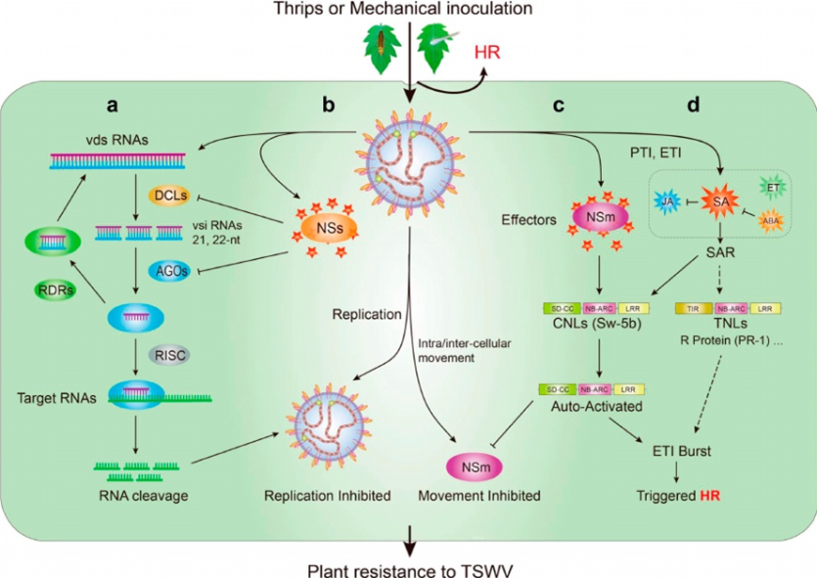
Figure 9 Mechanism of immune action of tomato against TSWV(Qi et al. 2021）

3.3Research progress of TGA transcription factors
3.3.1 Structural characteristics and classification of TGA transcription factors
The TGA gene family is a very important group in the bZIP transcription factor family. It can specifically bind to the activation sequence 1 (as-1) with TGACG as the core to regulate the transcription level of the target gene. It plays an important role and has application potential in the plant's defense response to biotic and abiotic stresses and the development of floral organs. Since the first TGA gene was identified in tobacco, genes of this family have been isolated and identified from multiple species such as Arabidopsis, rice and apple. There are 10 TGA transcription factors in the Arabidopsis genome, which can be divided into 5 groups based on their sequence similarity (Group I includes TGA1 and TGA4; TGA2, TGA5 and TGA6 form Group II; TGA3 and TGA7 form Group III; TGA9 and TGA10 constitute Group IV; PAN is Group V) (Gatz. 2013). Among them, members of groups I, II and III are widely involved in the disease resistance of plants. TGA1-TGA7 can interact with NPR1, a key regulator of the salicylic acid signaling pathway (Gatz. 2013). In addition to the conserved bZIP functional domain at the N-terminus, the Arabidopsis TGA family also contains two glutamine-rich Q1 and Q2 domains at the C-terminus. The N-termini of members of groups II and V also contain a conserved STDxDT phosphorylation site (Kesarwaniet al. 2007).
3.3.2 Disease resistance function of TGA transcription factors
TGA can play a role in the SA disease resistance signal transduction pathway. SA is an immune signal that accumulates rapidly after pathogen infection. It can trigger programmed cell death in local plants and induce plants to produce SAR, making plants broad-spectrum resistant to a variety of pathogens that subsequently invade (Herrera-Vásquezet al. 2015). SA can induce the accumulation of Arabidopsis pathogenesis-related protein genes (PR), which play an important role in resisting pathogen invasion. NPR1 (nonexpressor of pathogenesis related genes 1) is a SA receptor, and its mutants are more susceptible to disease than wild-type plants, and SA cannot induce SAR in mutant plants (Olate et al. 2018). Zhang et al. first used yeast two-hybrid technology to prove that the SA receptor NPR1 can interact with the three TGA transcription factors of group II (Zhang et al. 1999). It was subsequently proved that group I and group III TGA transcription factors can also interact with NPR1, but the strength of the interaction varies (Shearer et al. 2009).
TGA in JA/ethylene (Ethylene, ETH) disease resistance signal transduction pathway. In the process of plant disease resistance signal transduction, SA usually activates the resistance response against pathogens with PR-1 as the marker gene, while JA/ETH activates the resistance response against saprophytic parasites with PDF1.2 (PLANT DEFFENSIN 1.2, PDF1.2) as the marker gene. These two signal pathways usually show mutual antagonism. Studies have shown that group II TGAs can interact with glutaredoxins GRX480/ROXY19 (GRX), and overexpression of GRX480 strongly inhibits the expression of PDF1.2 induced by JA. However, in the npr1 mutant, the inhibitory effect of overexpression of GRX480 on PDF1.2 still exists, indicating that the inhibitory effect of GRX480-mediated PDF1.2 occurs downstream of NPR1 and is dependent on group II TGA (Ndamukong et al. 2007). TGA can also bind cytokinins (Cytokinin, CTK) and SA signaling pathway. Exogenous cytokinin enhances the expression of Arabidopsis SA biosynthesis genes and improves plant disease resistance, but in the tga3 mutant, CTK-induced PR-1 expression is lost, indicating that the plant immune response regulated by CTK may be related to the accumulation of SA and depends on the transcription factor TGA3 (Choiet al. 2010).
Previous studies have divided TGA9 and TGA10 into group IV, which have important regulatory functions in the development of floral organs in plants. The tga9/10 double mutant exhibits a phenotype of anther development defects (Murmuet al. 2010). However, subsequent studies have found that TGA9 in Arabidopsis is involved in regulating the production of reactive oxygen species (ROS) and subsequently affecting the expression of H2O2 response genes (Noshi et al. 2016). In addition, TGA9 has been shown to be involved in the activation of autophagy, which plays an important role in plant resistance to pathogens (including viruses, bacteria and fungi). Plant autophagy proteins interact with viral proteins to mediate their autophagic degradation, thereby better preventing viral invasion (Wang et al. 2020). In summary, TGA9 may play an important role in plant disease resistance. This study explores whether SlTGA9 in the disease-resistant material H149 can activate the up-regulated expression of Sl5R-1 by binding to the binding site in the promoter region of the Sl5R-1 gene, thereby strongly inducing HR response and SA accumulation, and conferring resistance to TSWV in H149 plants. This study is of great significance for enriching the functions of TGAs and the molecular mechanism of Sl5R-1 in resisting TSWV.

(IV) Research content

4.1 Construction of tomato Sl5R-1 knockout transformed plants based on CRISPR-Cas 9 gene editing technology and transcriptome analysis
4.1.1 Construction of Sl5R-1 gene knockout vector and genetic transformation

4.1.2 RNA-Seq analysis of TSWV-treated Sl5R-1 overexpression and knockout materials

4.2 Analysis of key signaling pathways affecting the anti-TSWV immune function of Sl5R-1

4.2.1Based on transcriptome differential enrichment analysis, RT-qPCR was used to verify the expression of key genes

4.2.2 Silencing candidate genes in Sl5R-1 overexpressing materials using VIGS technology and comparing their effects on disease resistance in Sl5R-1 overexpressing materials

4.2.3 Comparative analysis of the characteristics of immune responses involving key signaling pathways in Sl5R-1 overexpression and knockout materials and control plants after TSWV inoculation

4.3 Analysis of the role of transcription factor SlTGA9 in regulating the transcriptional expression of Sl5R-1
4.3.1 Silencing SlTGA9 in Sl5R-1 overexpressing materials or control plants using VIGS technology and comparing its effects on Sl5R-1 gene expression and plant disease resistance
4.3.2 Comparative analysis of the binding characteristics of transcription factor SlTGA9 and the promoter region of the gene of the resistant material Sl5R-1 using the dual luciferase reporter system
4.3.3 Further analysis of the key sites that affect the binding of transcription factor SlTGA9 to the promoter region of the Sl5R-1 gene through segmentation design

4.4 Based on transcriptome and proteome association analysis, further explore the key target proteins that interact with Sl5R-1

4.4.1 IP-MS analysis using the constructed Sl5R-1 overexpression material with GFP tag and control transformed plants

4.4.2. Screening of potential interaction targets of Sl5R-1 through correlation analysis of transcriptome and proteome (mass spectrometry data) data

4.4.3. Yeast two-hybrid and fluorescein interaction analysis were used to further verify the interaction between Sl5R-1 and candidate target proteins.

4.4.4 Verification of the effect of target protein on S15R-1-mediated immune function

(V) Research methods and technical routes

5.1 Research Methods
The disease-resistant material tomato H149 and the susceptible material tomato M82 both come from the tomato research group of the College of Horticulture, Northwest A&F University.
5.1.1 Extraction and detection of total genomic DNA from tomato materials
The tomato genomic DNA was extracted quickly by the modified CTAB method. The integrity of the tomato total DNA was detected by 1.2% agarose gel electrophoresis. The concentration and quality of the DNA were detected by a nucleic acid micrometer and stored at -20℃ for future use.
5.1.2 Total RNA extraction and detection of tomato materials
The conventional Trizol method was used to extract tomato total RNA, and the integrity of tomato total RNA was detected by 1.2% agarose gel electrophoresis. The concentration and quality of RNA were detected by a nucleic acid micrometer and stored at -80℃ for future use.
5.1.3 Analysis of promoter cis-acting elements
use(http://bioinformatics.psb.ugent.be/webtools/plantcare/html/) database website to analyze promoter cis-acting elements, using (http://plantregmap.gao-lab.org/) database website predicts transcription factors that regulate promoters.
5.1.4 Subcellular localization
The fusion expression vector of Sl5R-1 gene and pBI121-GFP was constructed and transformed into Agrobacterium strain GV3101. The transformed strain was used to infect Nicotiana benthamiana leaves. The subcellular localization of tomato Sl5R-1 gene was observed using laser confocal microscopy.
5.1.5 Vector construction and genetic transformation of tomato
Overexpression vectors and Case 9 knockout vectors were constructed for the cloned candidate genes, and the tomato genetic transformation system established by the research group was used to transform H149 and M82 by Agrobacterium-mediated method. Positive plants were screened by PCR identification, and qPCR was used to detect the differential expression of the target gene in transgenic plants and control plants.
5.1.6 Artificial inoculation of tomato materials with TSWV virus
When the tomato material grows to 6 true leaves, it is inoculated by artificial friction. During inoculation, TSWV is inoculated by friction with a 1ml syringe. The 3 true leaves above the 3rd true leaf are selected for inoculation. For each true leaf, 0.1ml TSWV is inoculated at the leaf margin, middle part and base of the 3 compound leaves. After inoculation, the greenhouse temperature is controlled at 22-27℃, the humidity is about 75%, and the insect net with more than 80 mesh is pulled to strictly prevent the invasion of external pests and diseases, and the disease situation is observed in the field in real time.
5.1.7 Transcriptome sequencing analysis of tomato TSWV-resistant materials
The Sl5R-1 knockout and overexpression materials of H149 were inoculated with TSWV virus when they had 6-8 true leaves. The young tomato leaves were collected at 0 dpi, 14 dpi, 21 dpi, and 35 dpi after inoculation with TSWV virus, and total RNA was extracted for transcriptome sequencing.https://solgenomics.net/) information, combined with bioinformatics analysis of highly expressed differentially expressed genes at the transcriptional level, and annotated the sequenced differentially expressed genes. Through Go and Pathway enrichment analysis, the disease resistance metabolic pathways involved in the anti-TSWV genes and the expression characteristics of the disease resistance candidate genes were found.
5.1.8 Co-immunoprecipitation combined with mass spectrometry analysis
The S15R-1 overexpressing material of H149 was inoculated with TSWV virus when the leaves were 6-8 true leaves.1cmThe total protein concentration was determined by punching three circular leaves with a hole punch.BCAThe protein screening steps were performed according to the PierceTM Co-Immunoprecipitation Kit operating instructions.IPThe protein samples were subjected to gel electrophoresis, and then the gel strips were cut and sent to a biological company for mass spectrometry identification. The raw data obtained were analyzed using Maxquant software to finally obtain the identified protein results.
5.1.9 Yeast One-Hybrid
The pHIS2.0 recombinant vector with the promoter fragment was transformed into the yeast strain Y187 by yeast small-scale transformation method, and then spread on plates containing different concentrations (10 mM, 20 mM, 30 mM, 40 mM, 50 mM, 60 mM) of 3-AT SD/-Trp-His. After culturing at 30°C for 7 days, the concentration of 3-AT plate with the least or no yeast plaques was observed, which was the optimal 3-AT concentration. Then the pHIS2.0 recombinant vector with the promoter fragment and the p with the transcription factor coding region fragment were transformed into the yeast strain Y187.GADT7. The recombinant vectors were co-transformed into yeast strain Y187 and then plated for verification.
5.1.10 Yeast two-hybrid
The bait protein was constructed into the pGBKT7 vector and transferred into the Y2H strain. The prey protein was constructed into the pGADT7 vector and transferred into the Y187 strain. By detecting the growth of the hybrid strain of pGBKT7-Bait (Y2H) and pGADT7 (Y18) on QDO medium, it was determined whether the bait protein had a direct interaction with the DNA activation domain. By detecting the growth of the hybrid strain of pGADT7-Prey (Y187) and pGBKT7 (Y2H) on QDO medium, it was determined whether the bait protein had a direct interaction with the DNA binding domain. Hybridize pGBKT7-Bait (Y2H) and pGADT7-prey (Y187), apply DDO to obtain the hybrid strain, and then apply QDO to verify the interaction.
5.1.11 Dual luciferase assay
After cloning, the transcription factor coding region was connected to the PGreenII62-SK vector, and the downstream gene promoter was cloned and connected to the PGreenII 0800-LUC vector. The constructed vectors were transformed into Agrobacterium with pSoup, and plated on the double-antibody LB solid medium containing kanamycin and rifampicin for subsequent experiments. The transformed Agrobacterium was picked up and the positive single clone was placed in the LB liquid medium containing kanamycin and rifampicin, and then transferred to a 50ml centrifuge tube and shaken until the OD600 of the bacterial solution was 0.6-0.8; the bacterial solution was centrifuged at 5000 rpm for 6 minutes to collect the bacteria, the supernatant was discarded, and the solution was resuspended with sterile water and centrifuged again. The supernatant was discarded, and about 10 ml of the prepared MES resuspension solution was added, and the suspension was resuspended. The LUC and SK bacterial solutions were mixed at a ratio of 5:1 or 10:1 and then left to stand for 2-3 hours. Select 4-6 week old wild type Nicotiana benthamiana and inject tobacco, with at least three replicates for each combination; keep tobacco moist after injection and culture in the dark for 3 days; punch holes around the injection hole to take samples (three replicates for each treatment), grind the samples; add 300 ul cell lysis buffer to each sample, mix thoroughly and let stand for 10 min in the dark (precool the centrifuge to 4°C at this time); after standing, centrifuge at 12000 rpm for 10 min, and aspirate the supernatant for 20 min.ulJoin 50ulLRB, measure its fluorescence value with a chemiluminescence instrument, then add LRBⅡ, measure the second fluorescence value (be careful to avoid light during this process), and perform data analysis.
5.1.12 EMSA assay
For the specific operation steps of the EMSA experiment, refer to the operating instructions of the Light Shift Chemiluminescent EMSA Kit (Thermo, USA). Dilute 15 U/uL of TdT to 1.5 U/uL, the system is: 2 uL of 5×TdT Reaction Buffer, 7 uL of ddH2O, 1 uL of 15 U/uL TdT, mix well, this mixture must be prepared and used immediately, and cannot be stored. After adding, incubate at 37℃ for 30 min, add 2.5 uL of 0.2 M EDTA to terminate the reaction, the probe binds to the recombinant protein, and then go through EMSA gel preparation (20 mL), electrophoresis, transfer to membrane, UV crosslinking, and finally chemiluminescence detection.
5.1.13 VIGS gene silencing
The conserved domains of candidate genes were predicted by the VIGS prediction tool on the Solanaceae genome website (https://vigs.solgenomics.net/), and VIGS silenced the conserved fragments. VIGS primers were designed using Primer Premier 5.0 software based on the conserved fragments of candidate genes. The length of upstream and downstream primers was controlled at 18-25 bp, and 15-25 bp of vector sequences containing restriction sites were added, the GC content was 40-60%, the annealing temperature was 54-65 ℃, and the PCR product size was 200-600 bp. VIGS vector construction was carried out by homologous recombination (DNA directional cloning technology), the reagent used was Hieff Clone® Plus Multi One Step Cloning Kit, and the tomato material was infected with Agrobacterium by injection of tomato plant cotyledons.
5.1.14 Fluorescence quantitative PCR (qPCR) analysis
Total RNA from leaves of tomato disease-resistant materials treated with TSWV virus at different stages was extracted and reverse transcribed into cDNA. Primers were designed by selecting specific sequences of 100-400 bp in the gene, and fluorescent quantitative PCR amplification was performed using SYBR® Premix Ex TaqTM kit and cDNA as template.2-ΔΔCtAnalysis method: Calculate relative gene expression.

5.2 Technical route

(VI) Expected Results
(1) Analyze the mechanism of action of transcription factor SlTGA9 in regulating the transcriptional expression of Sl5R-1;
(2) Preliminary revelation of the key interaction targets of Sl5R-1 and the immune signals it mediates.

VII. Innovation of this study
The disease-resistant materials used by our research group do not contain any reported TSWV-resistant genes. In addition, the gene Sl5R-1 studied is unique. The promoter region of this gene lacks an "A" base in the disease-resistant materials compared to the susceptible materials. The motif at this site may have disease-resistant function. This gene is highly conserved with the LRR domain of Sw-5b and is a typical R gene. No research has been reported before our research group..
Based on the created genetic transformation materials, this project used transcriptome and proteome association analysis to explore the key interaction targets of Sl5R-1 and its mediated immune signaling network, providing a new strategy for advancing tomato TSWV molecular breeding.

8. The main instruments, equipment and reagents required for graduate students engaged in natural science research, and the working conditions required for graduate students engaged in humanities and social sciences
Instruments and equipment:Constant temperature magnetic stirrer, ice maker, ultrapure water system, microplate reader, vertical electrophoresis tank, rotary mixer, vacuum pump, Q Exactive mass spectrometer, real-time fluorescence quantitative PCR, pipette, confocal microscope, real-time fluorescence quantitative PCR, gel imaging system, mortar, electrophoresis instrument, PCR instrument, centrifuge, spectrophotometer, constant temperature water bath, analytical balance, high pressure sterilization pot, constant temperature shaker, low temperature refrigerated centrifuge, clean bench, smart greenhouse, shed, etc.
Main reagents:Agarose gel recovery kit, plasmid extraction kit, first-strand synthesis kit, yeast transformation kit, TRIzol, CTAB, PBS, dimethyl sulfoxide, restriction endonuclease, DNA ligase, electrophoresis buffer, glycerol, silver staining reagent, agarose, various chromatography-grade and analytical-grade reagents, as well as primers, vectors, and E. coli, Agrobacterium strains, yeast strains, etc.

9. Arrangements for the progress of thesis work
2022.09-2023.01
1) Construction of Sl5R-1 gene knockout vector and genetic transformation;
2) Subcellular localization of Sl5R-1 protein;
3) The interaction between SlTGA9 and Sl5R-1 was verified by dual luciferase and yeast one-hybrid system.
20twenty three.02-20twenty three.08
1）The knockout stable transformed plants were used to identify and clarify the function of Sl5R-1 gene in resistance to spotted wilt;
2) VIGS silenced SlTGA9 in Sl5R-1 gene overexpressing materials or control plants, and analyzed the hypersensitive necrosis reaction and Sl5R-1 gene expression level before and after TSWV inoculation;
3) Through segmentation design, analyze the key sites that affect the binding of transcription factor TGA9 to the promoter region of the Sl5R-1 gene;
4）The Sl5R-1 knockout and overexpression materials of H149 were inoculated with TSWV virus when they had 6-8 true leaves, and the young tomato leaves were collected at 0dpi, 14dpi, 21dpi, and 35dpi for RNA-seq sequencing analysis.;
5) Analyze transcriptome sequencing data and screen Sl5R-1-related differentially expressed genes and anti-TSWV signal transduction pathways.
20twenty three.09-20twenty four.02
1）Sl5R-1Related differentially expressed genes fluorescence quantitative PCR;
2) VIGS silenced Sl5R-1-related differentially expressed genes in Sl5R-l transgenic materials, and measured hypersensitivity necrosis reactions and Sl5R-1 gene expression levels before and after TSWV inoculation;
3）The occurrence characteristics of immune responses involving key signaling pathways after Sl5R-1 overexpression and knockout materials and control plants were compared and analyzed after inoculation with TSWV.
20twenty four.02-20twenty four.08
1) Using the constructed Sl5R-1 overexpression material with GFP tag and the control transformed plants with GFP, IP-MS analysis was performed to screen for potential interaction targets of Sl5R-1;
2) Further verify the interaction between Sl5R-1 and candidate target proteins using yeast two-hybrid, fluorescein interaction analysis and immunoprecipitation techniques;
3) Organize the experimental data and write the experimental paper.
20twenty four.09-2025.02
1) Verify the effect of target protein on Sl5R-1-mediated immune function, silence genes encoding interacting proteins by VIGS in Sl5R-1 transgenic materials, measure allergic necrosis reaction and protein expression before and after TSWV inoculation, and expression change characteristics of key candidate genes;
2) Write and publish SCI papers.
2025.03-2025.06
1) Supplement and organize test data;
2) Write a doctoral dissertation;
3) Doctoral dissertation defense.

(X) Budget Estimates
project | Price (10,000 yuan)
SequencingCost of primers | 9
Equipment usage fee | 1.2
Reagents,Consumables | 3.5
Paper layout and printing fees | 1.6
Opening,Thesis review and defense fees  other | 0.6  0.8
total | 16.7

11. Technical difficulties encountered in the research work and the solutions to be adopted
1. The test results for verifying the interaction between genes and proteins may have false positive problems. Solution: Improve repetition and control during the test, and adopt multiple verification methods to reduce errors as much as possible.
2.RNA-seq and IP-MS require large amounts of data and take a long time to analyze. The accuracy of the analysis results has a significant impact on subsequent experiments.Solution:Combine database websites, data analysis software and other analysis methods with various test indicators to comprehensively analyze the results, reduce errors and reduce workload.

12. References
Liu Yunfei, Wan Hongjian, Wei Yanping, et al. Genome-wide analysis of the NBS-LRR disease resistance gene family in tomato[J]. Journal of Nuclear Agricultural Sciences, 2014, 28(05): 790-799.
Li Yunzhou, Mo Ning, Yan Jianmin, et al. Research progress on tomato spotted wilt virus disease[J]. Acta Horticulturae Sinica, 2018, 45(09): 1750-1760.
Gong Yunhe. Mining candidate genes of sugar beet NBS gene family for resistance to brown spot disease based on transcriptomics[D]. Heilongjiang University, 2022.
Mo Ning, Shi Yan, Qin Lei, et al. Cloning and analysis of the coat protein gene of tomato spotted wilt virus in Yangling, Shaanxi Province[J]. Chinese Vegetables, 2019(03): 36-40.
Qiu Shuliang, Wang Xiaoxuan, Du Yongchen, et al. Identification of Tomato Spotted Wilt Virus TSWV and screening of disease-resistant germplasm[J]. Acta Horticulturae Sinica, 2012, 39(6): 1107-1114.
Yin Yueyan, Li Tingting, Lu Xun, et al. Analysis of virus species in hosts and vectors of tomato spotted wilt virus disease using deep sequencing technology[J]. Acta Phytopathologica Sinica, 2018, 48(04): 501-508.
Asselbergh B, De Vleesschauwer D, Höfte M. Global switches and fine-tuning-ABA modulates plant pathogen defense[J]. Molecular Plant-Microbe Interactions, 2008, 21(6): 709-719.
Belkhadir Y, Subramaniam R, Dangl J L. Plant disease resistance protein signaling: NBS-LRR proteins and their partners[J]. Current Opinion in Plant Biology, 2004, 7(4): 391-399.
Berggård T, Linse S, James P. Methods for the detection and analysis of protein–protein interactions[J]. Proteomics, 2007, 7(16): 2833-2842.
Beris D, Theologidis I, Skandalis N, et al. Bacillus amyloliquefaciens strain MBI600 induces salicylic acid dependent resistance in tomato plants against Tomato spotted wilt virus and Potato virus Y[J]. Scientific Reports, 2018, 8(1): 1-11 .
Bjornson M, Zipfel C. Plant immunity: Crosstalk between plant immune receptors[J]. Current Biology, 2021, 31(12): R796-R798.
Bhatia G, Upadhyay SK, Upadhyay A, et al. Investigation of long non-coding RNAs as regulatory players of grapevine response to powdery and downy mildew infection[J]. BMC plant biology, 2021, 21(1): 1-16.
Brown MC, Gromeier M. MNK controls mTORC1: substrate association through regulation of TELO2 binding with mTORC1[J]. Cell reports, 2017, 18(6): 1444-1457.
Caplan J, Padmanabhan M, Dinesh-Kumar S P. Plant NB-LRR immune receptors: from recognition to transcriptional reprogramming[J]. Cell host & microbe, 2008, 3(3): 126-135.
Chen H, Qian X, Chen X, et al. Cytoplasmic and nuclear Sw‐5b NLR act both independently and synergistically to confer full host defense against tospovirus infection[J]. New Phytologist, 2021, 231(6): 2262-2281.
Chen Q, Jiang J, Zhang H, et al. Mining candidate genes associated with resistance to TYLCV in tomato based on BSA-seq and RNA-seq analysis[J].EuropeanJournal ofHorticulturalScience, 2020, 85(3): 145-159.
Chen Z, Wu Q, Tong C, et al. Characterization of the Roles of SGT1/RAR1, EDS1/NDR1, NPR1, and NRC/ADR1/NRG1 in Sw-5b-Mediated Resistance to Tomato Spotted Wilt Virus[J]. Viruses , 2021, 13(8): 1447.
Choi J, Huh SU, Kojima M, et al. The cytokinin-activated transcription factor ARR2 promotes plant immunity via TGA3/NPR1-dependent salicylic acid signaling in Arabidopsis[J]. Developmental cell, 2010, 19(2): 284-295 .
Ding SW, Voinnet O. Antiviral immunity directed by small RNAs[J]. Cell, 2007, 130(3): 413-426.
Fick A, Swart V, Van Den Berg N. The ups and downs of plant NLR expression during pathogen infection[J]. Frontiers in Plant Science, 2022, 13.
Jiang N, Cui J, Shi Y, et al. Tomato lncRNA23468 functions as a competing endogenous RNA to modulate NBS-LRR genes by decoying miR482b in the tomato-Phytophthora infestans interaction[J]. Horticulture research, 2019, 6.
Jones D R. Plant viruses transmitted by thrips[J]. European journal of plant pathology, 2005, 113(2): 119-157.
Jones JDG, Vance RE, Dangl J L. Intracellular innate immune surveillance devices in plants and animals[J]. Science, 2016, 354(6316): aaf6395.
Hamilton A J, Baulcombe D C. A species of small antisense RNA in posttranscriptional gene silencing in plants[J]. Science, 1999, 286(5441): 950-952.
Herrera-Vásquez A, Salinas P, Holuigue L. Salicylic acid and reactive oxygen species interplay in the transcriptional control of defense genes expression. Frontiers in Plant Science, 2015, 6: 171.
Huang, C. From player to pawn: Viral avirulence factors involved in plant immunity. Viruses 2021, 13, 688.
Huang C, Liu Y, Yu H, et al. Non-structural protein NSm of tomato spotted wilt virus is an avirulence factor recognized by resistance genes of tobacco and tomato via different elicitor active sites[J]. Viruses, 2018, 10(11 ): 660.
Huang H, Huang S, Li J, et al. Stepwise artificial evolution of an Sw‐5b immune receptor extends its resistance spectrum against resistance-breaking isolates of Tomato spotted wilt virus[J]. Plant biotechnology journal, 2021, 19(11) : 2164-2176.
Gatz C. From Pioneers to team players: TGA transcription factors provide a molecular link between different stress pathways. Molecular Plant-Microbe Interactions, 2013, 26(2): 151-159.
Kesarwani M, Yoo J, Dong X. Genetic interaction of TGA transcription factors in the regulation of pathogenesis-related genes and disease resistance in Arabidopsis. Plant Physiology, 2007, 144(1):336-346.
Kormelink R, Garcia ML, Goodin M, et al. Negative-strand RNA viruses: the plant-infecting counterparts[J]. Virus research, 2011, 162(1-2): 184-202.
Leonetti P, Stuttmann J, Pantaleo V. Regulation of plant antiviral defense genes via host RNA-silencing mechanisms[J]. Virology Journal, 2021, 18(1): 1-10.
Leon-Reyes A, Van der Does D, De Lange ES, et al. Salicylate-mediated suppression of jasmonate-responsive gene expression in Arabidopsis is targeted downstream of the jasmonate biosynthesis pathway[J]. Planta, 2010, 232(6): 1423-1432.
Lopez C, Aramburu J, Galipienso L, et al. Evolutionary analysis of tomato Sw-5 resistance-breaking isolates of Tomato spotted wilt virus[J]. Journal of General Virology, 2011, 92(1): 210-215.
Li J, Huang H, Zhu M, et al. A plant immune receptor adopts a two-step recognition mechanism to enhance viral effector perception[J]. Molecular plant, 2019, 12(2): 248-262.
Lin X, Zhang Y, Kuang H, et al. Frequent loss of lineages and deficient duplications accounted for low copy number of disease resistance genes in Cucurbitaceae[J]. BMC genomics, 2013, 14(1): 1-13.
Mandadi KK, Scholthof KB G. Plant immune responses against viruses: how does a virus cause disease?[J]. The plant cell, 2013, 25(5): 1489-1505.
Masri D, Alkowni R. Tomato spotted wilt disease in Palestine[J]. An-Najah University Journal for Research-A (Natural Sciences), 2021, 36(1): 39-50.
McMichael LA, Persley DM, Thomas J E. 2002. A new tospovirus serogroup IV species infecting capsicum and tomato in Queensland, Australia. Australasian Plant Pathology, 31(3): 231-239.
Meyers BC, Kozik A, Griego A, et al. Genome-wide analysis of NBS-LRR-encoding genes in Arabidopsis[J]. Plant Cell, 2003,15(4): 809-834.
Morca AF, Çelik A, Coşkan S, et al. Population analysis on tomato spotted wilt virus isolates inducing various symptoms on tomato, pepper, and Chenopodium album in Turkey[J]. Physiological and Molecular Plant Pathology, 2022, 118: 101786.
Murmu J, Bush MJ, DeLong C, et al. Arabidopsis basic leucine-zipper transcription factors TGA9 and TGA10 interact with floral glutaredoxins ROXY1 and ROXY2 and are redundantly required for anther development[J]. Plant Physiology, 2010, 154(3): 1492-1504.
Muthamilarasan M, Prasad M. Plant innate immunity: an updated insight into defense mechanism[J]. Journal of biosciences, 2013, 38(2): 433-449.
Nachappa P, Challacombe J, Margolies DC, et al. Tomato spotted wilt virus benefits its thrips vector by modulating metabolism and plant defense pathways in tomato[J]. Frontiers in Plant Science, 2020, 11: 575564.
Ndamukong I, Abdallat AA, Thurow C, et al. SA‐inducible Arabidopsis glutaredoxin interacts with TGA factors and suppresses JA‐responsive PDF1. 2 transcription[J]. The Plant Journal, 2007, 50(1): 128-139.
Niu C, Lu Y, Yuan Y, et al. Mapping resistance gene analogs (RGAs) in cultivated tetraploid cotton using RGA-AFLP analysis[J]. Euphytica, 2011, 181(1): 65-76.
Nivethaa PJ, Sidhdharth G. Transmission, Detection and Mapping Resistant Genes for Tomato Spotted Wilt Virus in Tomato[J]. Biotica Research Today, 2021, 3(9): 810-813.
Noshi M, Mori D, Tanabe N, et al. Arabidopsis clade IV TGA transcription factors, TGA10 and TGA9, are involved in ROS-mediated responses to bacterial PAMP flg22[J]. Plant Science, 2016, 252: 12-21.
Ocampo TO, Peralta SMG, Bacheller N, et al. Antiviral RNA silencing suppression activity of Tomato spotted wilt virus NSs protein[J]. Genetics and molecular research: GMR, 2016, 15(2).
Olate E, Jiménez-Gómez JM, Holuigue L, et al. NPR1 mediates a novel regulatory pathway in cold acclimation by interacting with HSFA1 factors[J]. Nature Plants, 2018, 4(10): 811-823.
Oliver JE, Whitfield A E. The genus Tospovirus: emerging bunyaviruses that threaten food security[J]. Annual review of virology, 2016, 3: 101-124.
Padmabhan C, Zheng Y, Shekaste-Band R, et al. Identification of defense-related genes associated with tomato Sw-7 line against Tomato spotted wilt virus in tomato through transcriptome analysis[J]. Phytopathology, 2016, 106: 161.
Padmanabhan C, Ma Q, Shekasteband R, et al. Comprehensive transcriptome analysis and functional characterization of PR-5 for its involvement in tomato Sw-7 resistance to tomato spotted wilt tospovirus[J]. Scientific reports, 2019, 9(1): 1-17.
Pappu HR, Jones RAC, Jain R K. Global status of tospovirus epidemics in diverse cropping systems: successes achieved and challenges ahead[J]. Virus research, 2009, 141(2): 219-236.
Phee BK, Shin DH, Cho JH, et al. Identification of phytochrome-interacting protein candidates in Arabidopsis thaliana by co-immunoprecipitation coupled with MALDI-TOF MS[J]. Proteomics, 2006, 6(12): 3671-3680.
Price DL, Memmott FD, Scott JW, et al. Identification of molecular markers linked to a new Tomato spotted wilt virus resistance source in tomato[J]. Tomato Genet. Coop, 2007, 57: 35-36.
Pruitt RN, Gust AA, Nürnberger T. Plant immunity unified[J]. Nature plants, 2021, 7(4): 382-383.
Qi S, Shen Y, Wang X, et al. A new NLR gene for resistance to tomato spotted wilt virus in tomato (Solanum lycopersicum)[J]. Theoretical and Applied Genetics, 2022, 135(5): 1493-1509.
Qi S, Zhang S, Islam MM, et al. Natural resources resistance to Tomato spotted wilt virus (TSWV) in tomato (Solanum lycopersicum)[J]. International Journal of Molecular Sciences, 2021, 22(20): 10978.
Rajarapu SP, Ben-Mahmoud S, Benoit JB, et al. Sex-biased proteomic response to tomato spotted wilt virus infection of the salivary glands of Frankliniella occidentalis, the western flower thrips[J]. Insect Biochemistry and Molecular Biology, 2022, 149 :103843.
Riley DG, Pappu H R. Tactics for management of thrips (Thysanoptera: Thripidae) and tomato spotted wilt virus in tomato[J]. Journal ofEconomicEntomology, 2004, 97(5): 1648-1658.
Roselló S, Díez MJ, Nuez F. Genetics of tomato spotted wilt virus resistance coming from Lycopersicon peruvianum[J]. European Journal of Plant Pathology, 1998, 104(5): 499-509.
Sáez C, Flores-León A, Montero-Pau J, et al. RNA-seq transcriptome analysis provides candidate genes for resistance to tomato leaf curl New Delhi virus in melon[J]. Frontiers in Plant Science, 2022: 3039.
Sandani HBP, Weerahewa HL D. Wilt diseases of tomato (Lycopersicum esculentum) and chilli (Capsium annum) and their management strategies: Emphasis on the strategies employed in Sri Lanka: A review[J]. Sri Lankan Journal of Biology, 2018, 3 (2).
Scholthof KBG, Adkins S, Czosnek H, et al. Top 10 plant viruses in molecular plant pathology[J]. Molecular plant pathology, 2011, 12(9): 938-954.
Sevik MA, Arli-Sokmen M. Estimation of the effect of Tomato spotted wilt virus (TSWV) infection on some yield components of tomato[J]. Phytoparasitica, 2012, 40(1): 87-93.
Sjokvist E, Lemcke R, Kamble M, et al. Dissection of Ramularia leaf spot disease by integrated analysis of barley and Ramularia collo-cygni transcriptome responses[J]. Molecular plant-microbe interactions, 2019, 32(2): 176-193 .
Shearer HL, Wang L, DeLong C, et al. NPR1 enhances the DNA binding activity of the Arabidopsis bZIP transcription factor TGA7[J]. Botany, 2009, 87(6): 561-570.
Soriano JM, Vilanova S, Romero C, et al. Characterization and mapping of NBS-LRR resistance gene analogs in apricot (Prunus armeniaca L.)[J]. Theoretical and Applied Genetics, 2005, 110(5): 980-989.
Stevens MR, Lamb EM, Rhoads D D. Mapping the Sw-5 locus for tomato spotted wilt virus resistance in tomatoes using RAPD and RFLP analyses[J]. Theoretical and Applied Genetics, 1995, 90(3): 451-456.
Stevens MR, Price DL, Memmott FD, et al. Identification of markers linked to Sw-7 a new Tomato spotted wilt virus resistance gene, derived from S. chilense[J]. Tomato Breeders Roundtable, 2007.
Tian H, Wu Z, Chen S, et al. Activation of TIR signaling boosts pattern-triggered immunity[J]. Nature, 2021, 598(7881): 500-503.
Turina M, Kormelink R, Resende R O. Resistance to tospoviruses in vegetable crops: epidemiological and molecular aspects[J]. Annu. Rev. Phytopathol, 2016, 54: 347-371.
Wang P, Nolan TM, Yin Y, et al. Identification of transcription factors that regulate ATG8 expression and autophagy in Arabidopsis[J]. Autophagy, 2020, 16(1): 123-139.
Yoon JY, Choi GS, Kwon SJ, et al. First report of Tomato spotted wilt virus infecting Peperomia obtusifolia in South Korea[J]. Plant Disease, 2019, 103(3): 593-593.
Yuan M, Ngou BPM, Ding P, et al. PTI-ETI crosstalk: an integrative view of plant immunity[J]. Current opinion in plant biology, 2021, 62: 102030.
Zamora O, Schulze S, Azoulay‐Shemer T, et al. Jasmonic acid and salicylic acid play minor roles in stomatal regulation by CO2, abscisic acid, darkness, vapor pressure deficit and ozone[J]. The Plant Journal, 2021, 108( 1): 134-150.
Zhan J, Shi H, Li W, et al. NbTMP14 is involved in tomato spotted wilt virus infection and symptom development by interaction with the viral NSm protein[J]. Viruses, 2021, 13(3): 427.
Zhang Y, Fan W, Kinkema M, et al. Interaction of NPR1 with basic leucine zipper protein transcription factors that bind sequences required for salicylic acid induction of the PR-1 gene[J]. Proceedings of the National Academy of Sciences, 1999, 96(11): 6523-6528.
Zhao X, Chen Z, Wu Q, et al. The Sw-5b NLR nucleotide-binding domain plays a role in oligomerization, and its self-association is important for activation of cell death signaling[J]. Journal of Experimental Botany, 2021 , 72(18): 6581-6595.
Zhou T, Wang Y, Chen JQ, et al. Genome-wide identification of NBS genes in japonica rice reveals significant expansion of divergent non-TIR NBS-LRR genes[J]. Molecular Genetics and Genomics, 2004, 271(4): 402-415.

